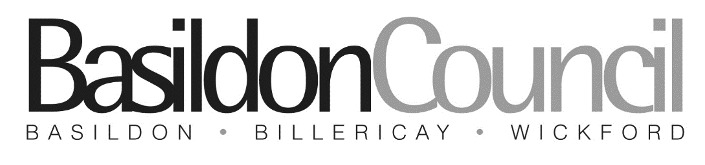

 | Department: | Business Rates
 | Phone: | 01268 533333
 | Email: | businessrates@basildon.gov.uk

APPLICATION FOR RATE RELIEF
LOCAL GOVERNMENT FINANCE ACT 1988
Rural Rate Relief

Information

1. What is the Rural Rate Relief Scheme?
The rural rate relief scheme was introduced to help protect the last retail outlets and similar services in rural settlements with a population of less than 3,000. The only Post Office, the only General Store, the only Public House, the only Petrol Filling Station, or a Food Shop in a Rural Settlement with a population not exceeding 3,000 is entitled to 100% Mandatory Relief if the Rateable Value does not exceed a specified amount.

2. How is Rural Rate Relief granted?
To be considered for Mandatory Relief, the attached application form should be completed and
returned. Mandatory Relief will normally be awarded each year whilst the qualifying criteria are
met. Discretionary Relief will normally be granted as percentage of the rates payable for a
specific period.

3. What is the qualifying criteria?
The Rateable Value of the property at the beginning of the rating year must not exceed a
specified amount, and the business must be located in a qualifying Rural Settlement.
For the Post Office or General Store (All the following criteria must be met):
- The Rateable Value of the property must not exceed £8,500
- The property must be used as a Post Office or a General Store, or both.
- The property must be the only Post Office or the only General Store in the Rural Settlement.
For a Village Food Shop (All the following criteria must be met):
- The Rateable Value of the property must not exceed £8,500
- The property must be used as a shop selling mainly food.
For a Public House or Petrol Filling Station (All the following criteria must be met):
- The Rateable Value of the property must not exceed £12,500
- The property must be used as a Public House or a Petrol Filling Station
- The property must be the only Public House or Petrol Filling Station in the Rural Settlement.
- Name of Ratepayer
- Property Address on which Rural Rate Relief is being claimed
- Business Rates Reference Number (See your Rates Bill, 10 digits, starts ‘17’
- Rateable Value
- Purpose for which the property is used: | Is the property used wholly or mainly as a General Store? YES / NO  Is the property used as a Post Office? YES / NO  Is all or part of the property used as a Public House? YES / NO  Is all or part of the property used as a Petrol Filling Station? YES / NO  Is the property used wholly or mainly for any purpose other than a General Store, Post Office, Public House, Petrol Filling Station or Food Shop? YES / NO
- How does your business benefit the local community and why do you consider that your business is important to the maintenance of village life? Please provide a brief explanation and continue on another sheet if necessary
Declaration

I apply for Rural Rate Relief and I declare that the information given on this form and in any supporting documents is correct. I authorise the local taxation office to make any enquiries necessary to verify the information stated.

I will notify the Local Taxation Office of any change of circumstances affecting the property.

I understand that I am not entitled to withhold payment of Rates pending the determination of this application.

Signed………………………………………………………... Date.……./……./………..
Name of Signatory…………………………….. Capacity in which signed…………………..............
Email address…………………………………………………
Daytime Telephone Number (in the event of any query)…………………………………………………..

