Wednesday 12th July 2023  Departs at 9am from Laindon Activity Centre  Clacton Day Trip  Cost (LAC User) £12  Cost (LAC Mem) £14  Cost (Non Mem) £17  Seats still available | 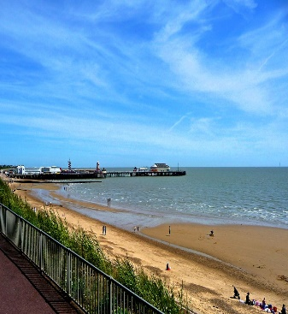
Wednesday 26th July 2023  Departs at 12 noon from Laindon Activity Centre**  Lingfield Park Horseracing includes admission, race card, a Traditional pie, a drink (wine/beer or soft drink)  Cost (LAC User) £36  Cost (LAC Mem) £38  Cost (Non Mem) £41  Minimum deposit £20  2 seats available **please note new departure time | 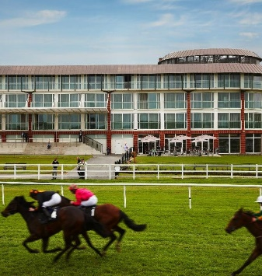
Saturday 5th August 2023  Departs at 9am from Laindon Activity Centre  Hastings Day Trip  Cost (LAC User) £14  Cost (LAC Mem) £16  Cost (Non Mem) £19  To be paid in full when booking  Seats still available | 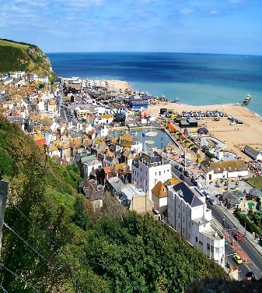
Thursday 10th August 2023  Departs at 8.45am from Laindon Activity Centre  Buckingham Palace  Cost (LAC User) £39  Cost (LAC Mem) £41  Cost (Non Mem) £44  Entrance to Palace at 11am plus free time for lunch afterwards | 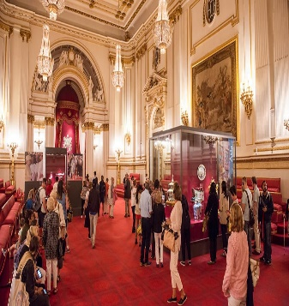
Thursday 24th August 2023  Departs at 8.30am from Laindon Activity Centre  An Indian Summer in West Sussex  Cost (LAC User) £62  Cost (LAC Mem) £64  Cost (Non Mem) £66  Please see notice board for more details  1 seat available | 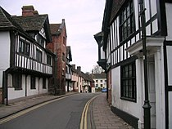  This Photo by Unknown Author is licensed under CC BY-SA
Saturday 2nd September 2023  Departs at 8.30am from Laindon Activity Centre  Windsor Boat trip with free time in Windsor  Includes ploughman’s lunch on board the boat  Please note the bar is cash only on the boat  Cost (LAC Mem) £47  Cost (Non Mem) £52  Register interest from Monday 26th June.  Payments from Monday 9th July | 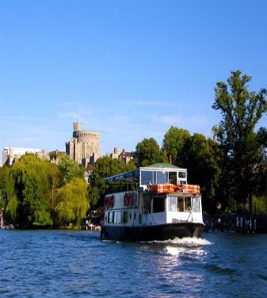
Friday 22nd September 2023  Departs at 9am from Laindon Activity Centre  Suffolk Villages Tour & Saffron Walden  Includes morning coffee in Finchingfield  and a 2 course lunch in Long Melford  Cost (LAC Mem) £55  Cost (Non Mem) £60  1 seat available | 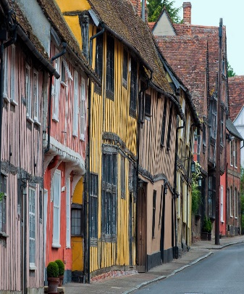
Thursday 5th October 2023
Departs at 11am from Laindon Activity Centre
Ain’t Too Proud Show
Prince Edward Theatre London
Cost (LAC Mem) £53
Cost (Non Mem) £58

Register interest from Monday 3rd July.
Payments from Monday 7th August

Thursday 2nd November 2023  Departs at 12.30pm from Laindon Activity Centre  Romford Dogs  Includes a 3 course lunch  Cost (LAC Mem) £28  Cost (Non Mem) £33  Register interest from Monday 17th July  Payments from Wednesday 16th August | 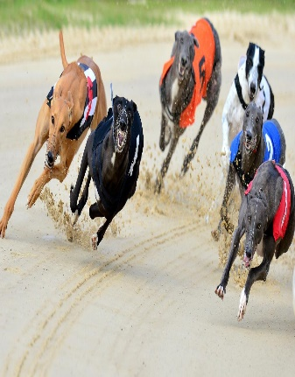
Wednesday 6th December 2023  Departs at 9am from Laindon Activity Centre  The Christmas Beatles Show Party Lunch  Prince Regent Hotel Chigwell  Tea/Coffee/Mince Pies on arrival  3 course festive lunch  Prize for best dressed Sgt.Pepper/1960’s theme  Cost (LAC Mem) £57  Cost (Non Mem) £62  Register interest from Tuesday 29th August  Payment from Wednesday 27th September | 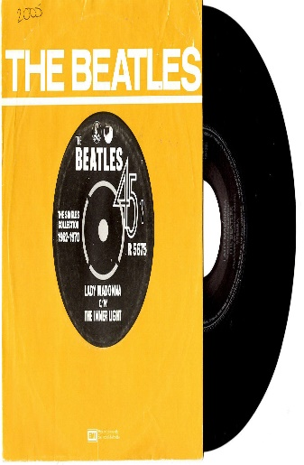
Monday 20th to Friday 24th November 2023  Departure time: TBA  Turkey and Tinsel, Sinah Warren, Hayling Island  4 nights half board  Cost (LAC User) £350 Deposit £50  Cost (LAC Mem) £352 Deposit £52  Cost (Non Mem) £355 Deposit £55  Followed by 5 monthly payments of £60  1 twin room available | 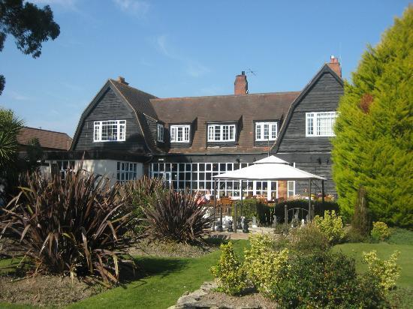
Monday 24th to Friday 28th June 2024  Departure time: TBA  Potters Resort, Hopton-on-Sea  4 nights – all inclusive  Hotel Bungalow  Cost (LAC Mem) £694 Cost (LAC Mem) £557  Cost (Non Mem) £699 Cost (Non Mem) £562  Dep: £109(Mem) /£114(NM) Dep:£62(Mem)/£67(NM)  Register interest with office  Deposits from Monday 24th July | 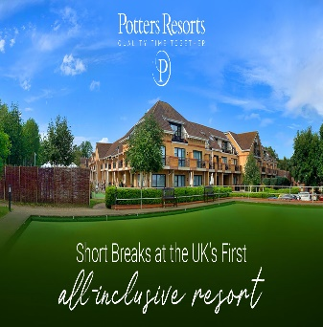

IN-HOUSE EVENTS
Tues. 15TH & 22ND August: Choir Charity Concerts
Time: 1pm £2 per ticket
Tickets on sale 31st July

